Exercise 1

* Low Level Design
* Software Development Practices
* Hands-on Programming

There is 3 type User exist :

1. Employee
2. Affiliate
3. Customer

Class Diagram

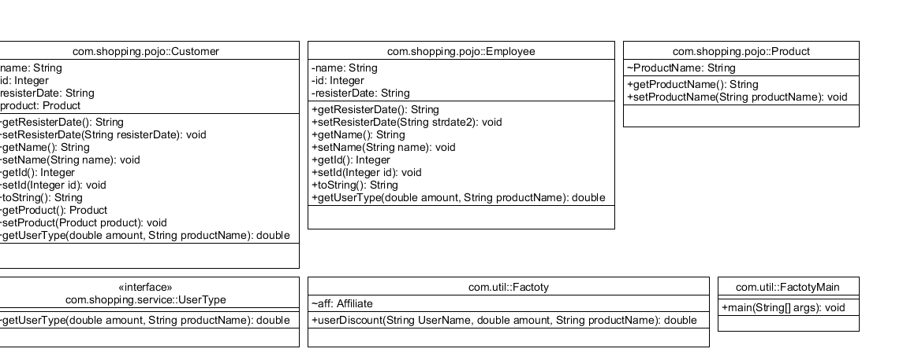

**Design Note**

**Component changes :**

**public** **interface** UserType {

**double** getUserType(**double** amount,String productName);

}

**public** **class** Product {

String ProductName;

**public** String getProductName() {

**return** ProductName;

}

**public** **void** setProductName(String productName) {

ProductName = productName;

}

}

**public** **class** Customer **implements** UserType{

**private** String name ;

**private** Integer id;

**private** String resisterDate;

**private** Product product;

@Override

**public** **double** getUserType(**double** amount,String productName) {

**double** pay=amount;

**if**(!productName.equals("groceries")) {

**double** quotient = (amount*5)/100;

pay = amount - quotient;

**return** pay;

}

**return** pay;

}

**public** **class** Affiliate **implements** UserType {

**private** String name ;

**private** Integer id;

**private** String resisterDate;

**private** Product product;

@Override

**public** **double** getUserType(**double** amount,String productName) {

**double** pay=amount;

**if**(!productName.equals("groceries")){

**double** quotient = (amount*10)/100;

pay = amount - quotient;

**return** pay;

}

**return** pay;

}

**public** **class** Employee **implements** UserType{

**private** String name ;

**private** Integer id;

**private** String resisterDate;

@Override

**public** **double** getUserType(**double** amount,String productName) {

**double** pay=amount;

**if**(!productName.equals("groceries")){

**double** quotient = (amount*30)/100;;

pay = amount - quotient;

**return** pay;

}

**return** pay;

}

**public** **class** DiscountProduct {

**public** **static** **double** userGetDiscount(String UserName, **double** amount, String productName) **throws** ParseException {

Affiliate aff = **new** Affiliate();

aff.setName("sushil");

String strdate1 = "02-04-2019 11:35:42";

aff.setResisterDate(strdate1);

Customer cus = **new** Customer();

cus.setName("Rohit");

String strdate2 = "02-04-2019 11:35:42";

cus.setResisterDate(strdate2);

Employee emp = **new** Employee();

emp.setName("Mohit");

String strdate3 = "02-04-2019 11:35:42";

emp.setResisterDate(strdate3);

**double** paymentAfterDiscount = 0;

**if** (UserName.equalsIgnoreCase(aff.getName())) {

paymentAfterDiscount = aff.getUserType(amount, productName);

} **else** **if** (UserName.equals(cus.getName())) {

paymentAfterDiscount = cus.getUserType(amount, productName);

} **else** **if** (UserName.equals(emp.getName())){

SimpleDateFormat obj = **new** SimpleDateFormat("MM-dd-yyyy HH:mm:ss");

Date date1 = obj.parse("12-12-2018 02:11:20");

Date date2 = obj.parse("1-26-2020 07:15:50");

**long** time_difference = date2.getTime() - date1.getTime();

**long** hours_difference = (time_difference / (1000 * 60 * 60)) % 24;

**if** (hours_difference > 2) {

paymentAfterDiscount = cus.getUserType(amount, productName);

}

} **else** {

**double** quotient = amount / 100;

paymentAfterDiscount = amount - (quotient * 5);

}

**return** paymentAfterDiscount;

}

}

**public** **class** FactotyMain {

**public** **static** **void** main(String[] args) {

**try** {

//System.out.println(Factoty.userDiscount("Sushil", 500, "Electronics"));

System.***out***.println(Factoty.*userDiscount*("Mohit", 500, "Electronics"));

} **catch** (ParseException e) {

// **TODO** Auto-generated catch block

e.printStackTrace();

}

}